**Analysing Housing Prices in Metropolitan Areas of India**

**Project Report**

**TEAM MEMBERS**

S. MEENAKSHI

C.MONIKA SRI

S.MOHANA LAKSHMI

N.MOWNITHAMBAL

1. INTRODUCTION

1.1 OVERVIEW

Since the inception of the theory and the idea of development, common future that emerged in different point of time is the development gap that emerged parts of the world and also among various parts of the country in particular time period.

1.2 PURPOSE

The HPI is the one of many economic indicators that investor use to keep pulse on broader economic trends and potential shifts in the stock markets the rise and fall of house price can have big implications for the economy

2. PROBLEM DEFINITION AND DESIGN THINKING

2.1 EMPATHY MAP

2.2 IDEATION AND BRAINSTORMING MAP

3. RESULT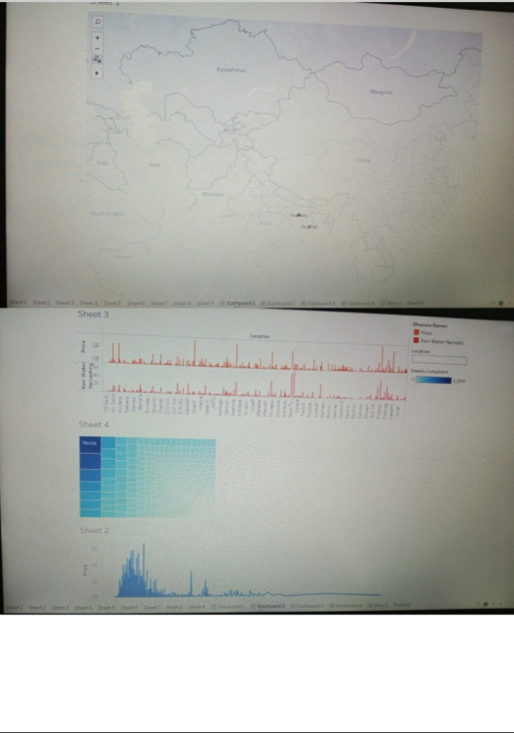

4. ADVANTAGES AND DISADVANTAGES

Some of the advantage and disadvantages

ADVANTAGES

* High speed internet access in the form fiber and 5G
* Wide varieties of restaurants to order from.
* Presence of an international airport.
* One day delivery of products including essential like medicine
* Head office
* Modern infrastructure and better and applications of technology.

DISADVANTAGES

* High cost of rent and food
* Overpopulation and pollution
* Increase competition and societal callousness.

5. APPLICATIONS

House price prediction can help the developer determine the selling price of a house and can help the customer to arrange the right time to purchase the house there are three factors that influence the price of a house which include physical condition concept and location

6. CONCLUSION

Based on the criterion of the price convergences , house prices in the 15 metropolitan cities do not converges to loop this implies that the housing market in the different areas operate has segmented independent local markets therefore, house prices in one location in India cannot impose a competitive constraint on house price in other location, and search a home owner can freely set the price of his house.

7. FUTURE SCOPE

The future scope of the topic is property prices in India are expected to increase 7.5 percent on a pan India basis this year, the fastest growth in five years according to property analysts. Average house price forecast to rise 6 percent next year.